EXP. NO:  3 | MATLAB-BASED MODELLING OF VSB MODULATOR AND DEMODULATOR FOR ANALOG TELEVISION  COMMUNICATION APPLICATIONS
DATE:

Objectives:
i) To generate and analyse the Vestigial Sideband (VSB) modulated signal by performing DSB-SC modulation and applying a suitable filter using MATLAB.
ii) To implement coherent demodulation and recover the original message signal from the VSB signal, and compare the transmitted and recovered waveforms.
Procedure
1. Open MATLAB and create a new script file.
2. Define the simulation parameters such as sampling frequency, message frequency, carrier frequency, and time vector.
3. Generate the message signal using a low-frequency cosine waveform.
4. Generate the carrier signal using a high-frequency cosine waveform.
5. Perform DSB-SC modulation by multiplying the message signal with the carrier signal. 6. Design a Butterworth filter to approximate the Vestigial Sideband (VSB) filter. 7. Apply the VSB filter to the DSB-SC signal to obtain the VSB modulated signal.
8. Perform coherent demodulation by multiplying the VSB signal with a synchronized carrier signal.
9. Design and apply a low-pass filter to the demodulated signal to recover the original message signal.
10. Plot the message signal, carrier signal, DSB-SC signal, VSB signal, demodulated signal, and recovered message signal using MATLAB subplots.
11. Compare the recovered message signal with the original message signal to verify successful modulation and demodulation.
12. Analyze the simulation results and conclude the performance of the VSB modulation and demodulation process for analog television communication applications.

OBJECTIVE 1:
To generate and analyse the Vestigial Sideband (VSB) modulated signal by performing DSB-SC modulation and applying a suitable filter using MATLAB.

PROGRAM (MATLAB CODE) :
%% EXP 3 - Objective 1: VSB Signal Generation & Filtering
clc;
clear;
close all;

% Simulation Parameters
fs = 100000; % Sampling frequency (Hz)
t = 0:1/fs:0.02; % Time vector (20 ms duration)
fm = 500; % Modulating message frequency (Hz)
fc = 5000; % Carrier frequency (Hz)

% Signal Generation
m = cos(2 * pi * fm * t); % Low-frequency message signal
c = cos(2 * pi * fc * t); % High-frequency carrier signal

% Step 1: DSB-SC Modulation (Multiplication)
dsb = m .* c;

% Step 2: VSB Filter Design & Filtering
% 4th-order Butterworth filter centered around the carrier frequency
[b, a] = butter(4, fc / (fs / 2));
vsb = filter(b, a, dsb);

% Plotting Time-Domain Waveforms
figure('Name', 'Objective 1: VSB Modulation Process', 'NumberTitle', 'off');

subplot(4,1,1);
plot(t, m, 'LineWidth', 1.2);
title('1. Modulating Message Signal m(t)');
xlabel('Time (s)'); ylabel('Amplitude');
grid on;

subplot(4,1,2);
plot(t, c, 'LineWidth', 1.1);
title('2. Carrier Signal c(t)');
xlabel('Time (s)'); ylabel('Amplitude');
grid on;

subplot(4,1,3);
plot(t, dsb, 'LineWidth', 1.1);
title('3. DSB-SC Modulated Signal');
xlabel('Time (s)'); ylabel('Amplitude');
grid on;

subplot(4,1,4);
plot(t, vsb, 'LineWidth', 1.2);
title('4. VSB Modulated Signal (After Vestigial Filter)');
xlabel('Time (s)'); ylabel('Amplitude');
grid on;
OUTPUT (GRAPH)
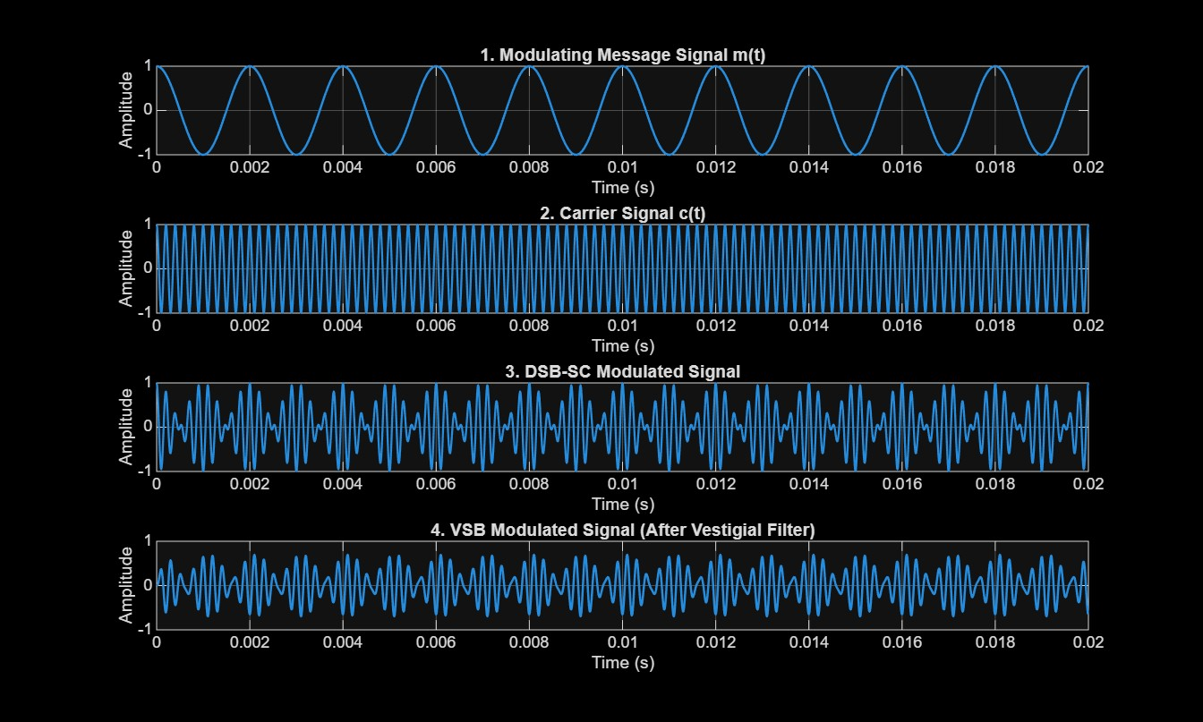

Result 1:
i) The VSB modulated signal was successfully generated from the DSB-SC signal using MATLAB and verified through the displayed waveforms.
ii) The original message signal was successfully recovered through coherent demodulation and low-pass filtering, confirming the correct implementation of the VSB communication system.

OBJECTIVE 2:
To implement coherent demodulation and recover the original message signal from the VSB signal, and compare the transmitted and recovered waveforms.
PROGRAM:
%% EXP 3 - Objective 2: Coherent Demodulation & Waveform Comparison
clc;
clear;
close all;

% Parameters
fs = 100000; % Sampling frequency (Hz)
t = 0:1/fs:0.02; % Time vector
fm = 500; % Message frequency (Hz)
fc = 5000; % Carrier frequency (Hz)

% Transmitted Signals
m = cos(2 * pi * fm * t);
c = cos(2 * pi * fc * t);
dsb = m .* c;

% VSB Filtering
[b, a] = butter(4, fc / (fs / 2));
vsb = filter(b, a, dsb);

% Step 1: Coherent Demodulation (Synchronous Carrier Mixing)
demod = vsb .* (2 * cos(2 * pi * fc * t));

% Step 2: Low-Pass Filter (Cutoff at 1000 Hz to recover 500 Hz message)
[b1, a1] = butter(4, 1000 / (fs / 2));
rec = filter(b1, a1, demod);

% Comparison & Signal Verification
figure('Name', 'Objective 2: Coherent Demodulation & Recovery', 'NumberTitle', 'off');

subplot(3,1,1);
plot(t, demod, 'k', 'LineWidth', 1);
title('Demodulated Signal (Before Low-Pass Filtering)');
xlabel('Time (s)'); ylabel('Amplitude');
grid on;

subplot(3,1,2);
plot(t, rec, 'r', 'LineWidth', 1.5);
title('Recovered Message Signal (After LPF)');
xlabel('Time (s)'); ylabel('Amplitude');
grid on;

subplot(3,1,3);
plot(t, m, 'b--', 'LineWidth', 1.5); hold on;
plot(t, rec, 'r', 'LineWidth', 1.2);
legend('Original Message m(t)', 'Recovered Message', 'Location', 'northeast');
title('Comparison: Original vs Recovered Message');
xlabel('Time (s)'); ylabel('Amplitude');
grid on;

fprintf('--- Objective 2 Verification ---\n');
fprintf('Message Frequency : %d Hz\n', fm);
fprintf('Carrier Frequency : %d Hz\n', fc);
fprintf('Coherent demodulation and LPF reconstruction completed successfully.\n');

OUTPUT GRAPH:
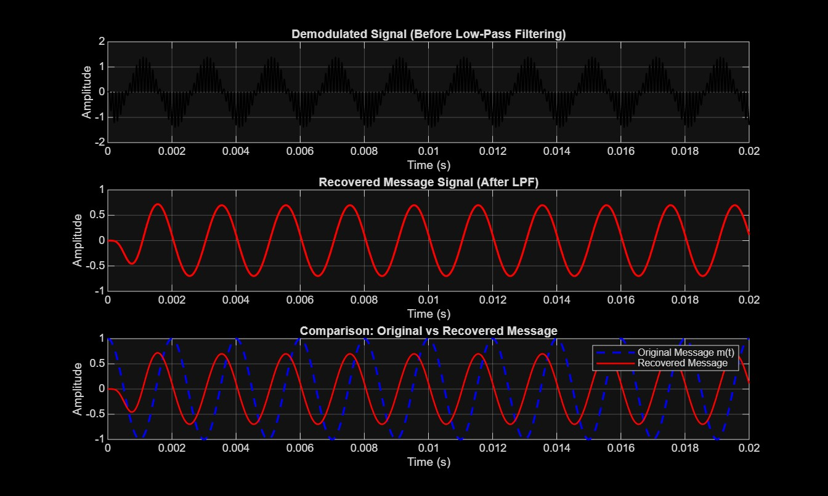
VERIFICATION:
--- Objective 2 Verification ---
Message Frequency : 500 Hz
Carrier Frequency : 5000 Hz
Coherent demodulation and LPF reconstruction completed successfully.

